Packet Tracer - Configuring Switch Port Security

1. Topology

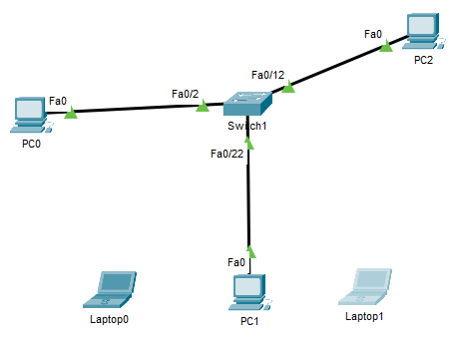

1. Configure Port Security
   * 1. Enable port security on Fast Ethernet ports 0/1 - 0/12, and 0/22.
        1. Set the maximum so that only one device can access the Fast Ethernet ports 0/1 – 0/12.
        2. Secure the ports so that the MAC address of a device is dynamically learned and added to the running configuration.
        3. Set the violation so that the Fast Ethernet ports 0/1 and 0/2 are not disabled when a violation occurs, but packets are dropped from an unknown source.
     2. Enable port security on Fast Ethernet ports 0/13 - 0/21.
        1. Set the port security for static MAC addresses as follows:
           1. Port 13 - 1234.5678.9abc, violation is shutdown.
           2. Port 14 - 4123.5678.9abc, violation is shutdown.
           3. Port 15 - 3412.5678.9abc, violation is shutdown.
           4. Port 16 - 2341.5678.9abc, violation is restrict.
           5. Port 17 - 1234.8567.9abc, violation is restrict.
           6. Port 18 - 1234.7856.9abc, violation is restrict.
           7. Port 19 - 1234.6785.9abc, violation is protect.
           8. Port 20 - 1234.5678.c9ab, violation is protect.
           9. Port 21 - 1234.5678.bc9a, violation is protect.

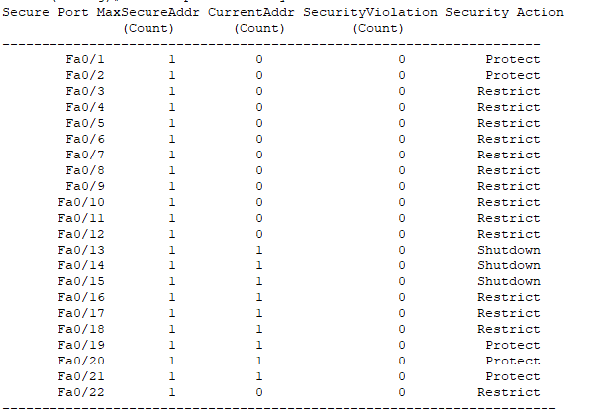

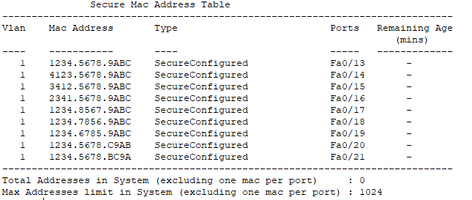

1. Verify Port Security
   * 1. From PC0, ping PC1, and PC2.
     2. Verify port security is enabled and the MAC addresses of **PC1** and **PC2** were added to the running configuration.
        1. What command (s) did you use to accomplish this?

Show running-config

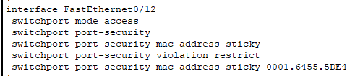

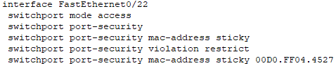

* + 1. Attach **Laptop** 0 to port 6
       1. Are you able to ping the 3 x PCs?_____Yes, I am._________
       2. What is the status of the port security on port 6?_____Secure-up________________
       3. What command did you use? _______show port-security interface f0/6________________.

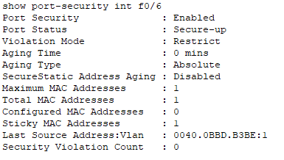

* + 1. Attach Laptop 1 to port 15.
       1. Are you able to ping the 3 x PCs?_________No___________
       2. What is the status of the port security on port 15?_________Secure-shutdown____________
       3. What command did you use? _________show port-security interface f0/15______________.

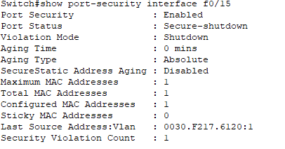

* + 1. Disconnect PC2 and connect **Laptop** 1 to port 12.
       1. Are you able to ping the 3 x PCs?__________No__________
       2. What is the status of the port security on port 12?_________Secure up_______

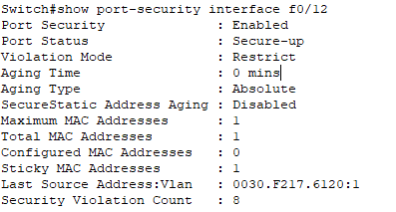

* + 1. Disconnect **Laptop** 1 and reconnect **PC2**.
       1. Are you able to ping the other two PCs?______Yes______________
       2. What is the status of the port security on port 12?_____________Sercure up________
    2. 